Thomas Jubb

MMA League Table
Computer Science NEA

Contents
Research Into Existing Systems 3
Stakeholders 13
Investigation Method 1 15
Investigation Method 2 22
Investigation Method 3 24
Document Collection 27
Processing 30
Limitations 31
Working specification 32
Justifications of the methods to be used. 33
Objectives and success criteria 34

Research Into Existing Systems
  - Existing System Example 1 – Tapology
Tapology is an MMA website which shows rankings, news and upcoming fights.
Features
- The page shows which fights are about to happen, and how it also lets you enter a prediction.
- When the page shows what fights are about to happen, it also has two pictures of each of the fighters that will be fighting in the bout and their names.
- You can also search for individual fighters, bouts and events.
- The Tapology system shows the main pages of the website on top.
- In the rankings page, at the top, you are given the option to sort the rankings by 4 broad categories.
- The rankings page shows the major trending changes to the rankings at the top and shows a graph of the rankings change for all the fighters
- Below that, it shows the ranking changes to all the elite fighters.
- The website also shows the top 50 ranking changes in a table form
- The website shows individual ranking boards in a large table format
- The table has the ranking first, then a picture of the fighter. It then shows information about the fighter, and then their record, finally.
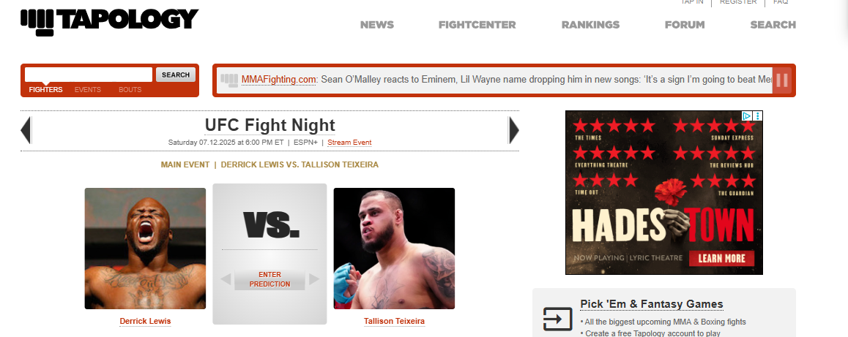
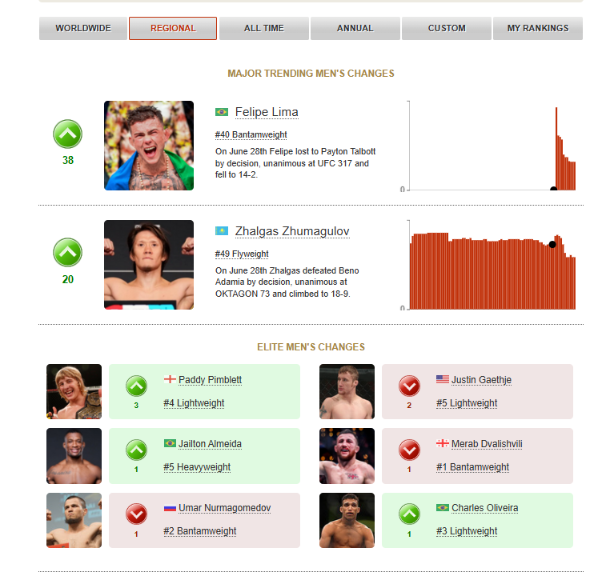
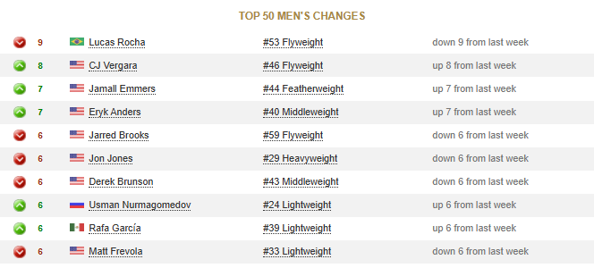
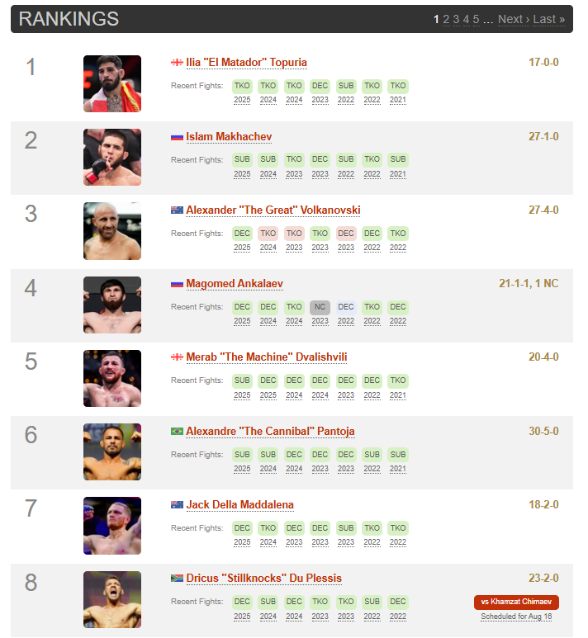

Takeaways
- I like the idea of being able to see the ranking changes of the elite fighters first, as they have the most impact, so in my system, I would probably just take away the trending rank changes part and just have the elite.
- I like the colour scheme because it’s easy to read and take in quickly, so I will adapt something like that into my project, such as a higher contrast two-tone scheme.
- I like the use of a table to show ranking changes, and I think I could make this look good in my project in a SQL table
- I like how you can enter the prediction for the fights that are about to happen. In my project, I could add to this by also adding the ability to vote on the entertainment of a fight.
- I like how you can gauge the fighters at the event by seeing a photo of them both. I think that it would make it easier to see what kind of fight you’re getting by adding more information about both fighters. Main things would be rankings and records, but I could also add things like the odds.
- I think that it’s a good idea to include the ability to search for individual fighters if you want to look at their stats. I don’t really think that adding the bouts is necessary, as you’ll see that information on the fighter’s page anyway. Also, the system I’m making is focused on the fighters themselves, so I don’t really think that I need the information about an event, either, meaning that I will add these
- I personally like this way of showing rankings in a large table format a lot. I think the large table format makes all the information stored way easier to digest, so I will try to make my table big.
- I like having a lot of fighter images available, but I may be limited in the way I can display lots of images at the same time from the SQL database
- I like the little flag which tells you which fighter is from which country. If I can find a way to implement it properly, I will add it.
- I don’t like the order of the table. In my opinion (and what’s going to be in my project), the name should be first, so you can read the names of each number ranking quicker, instead of having the picture of the fighter

  - Existing System Example 2 – UFC Official Website
- The front page of the UFC website shows every ranking with the champion’s image at the top of each weight class ranking
- If you aren’t the champion, the chart only shows your rank, name and rank change.
- For each fighter, it shows a picture of them, their division, their record, their win streak, the ways they’ve won their previous fights and their upcoming and last fights.
- It also shows tags which tell you other info, like if the fighter is a champion, if they’re active
- Under that part, it shows 7 different boxes, which show different stats
- These stats come with charts a couple of times. For this example, there are two pie charts and heatmaps based on significant strikes
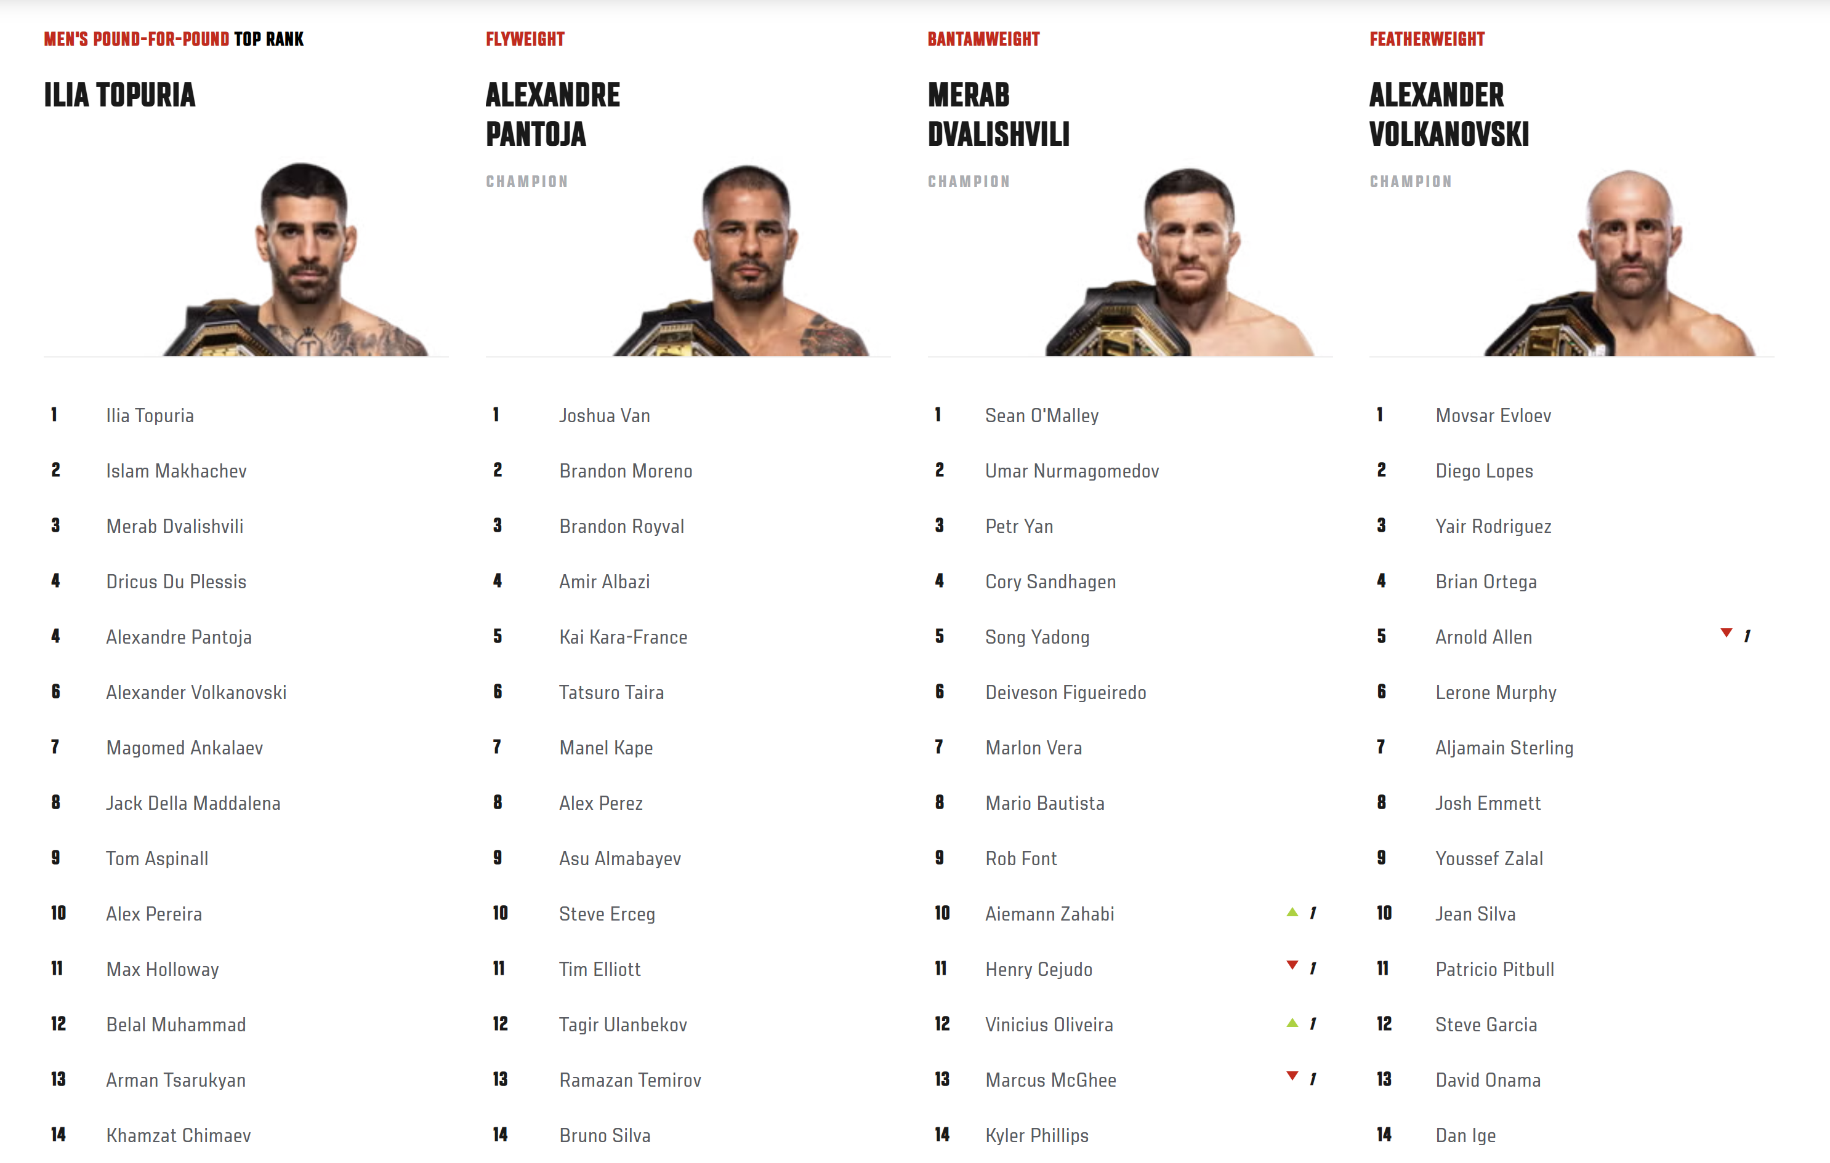
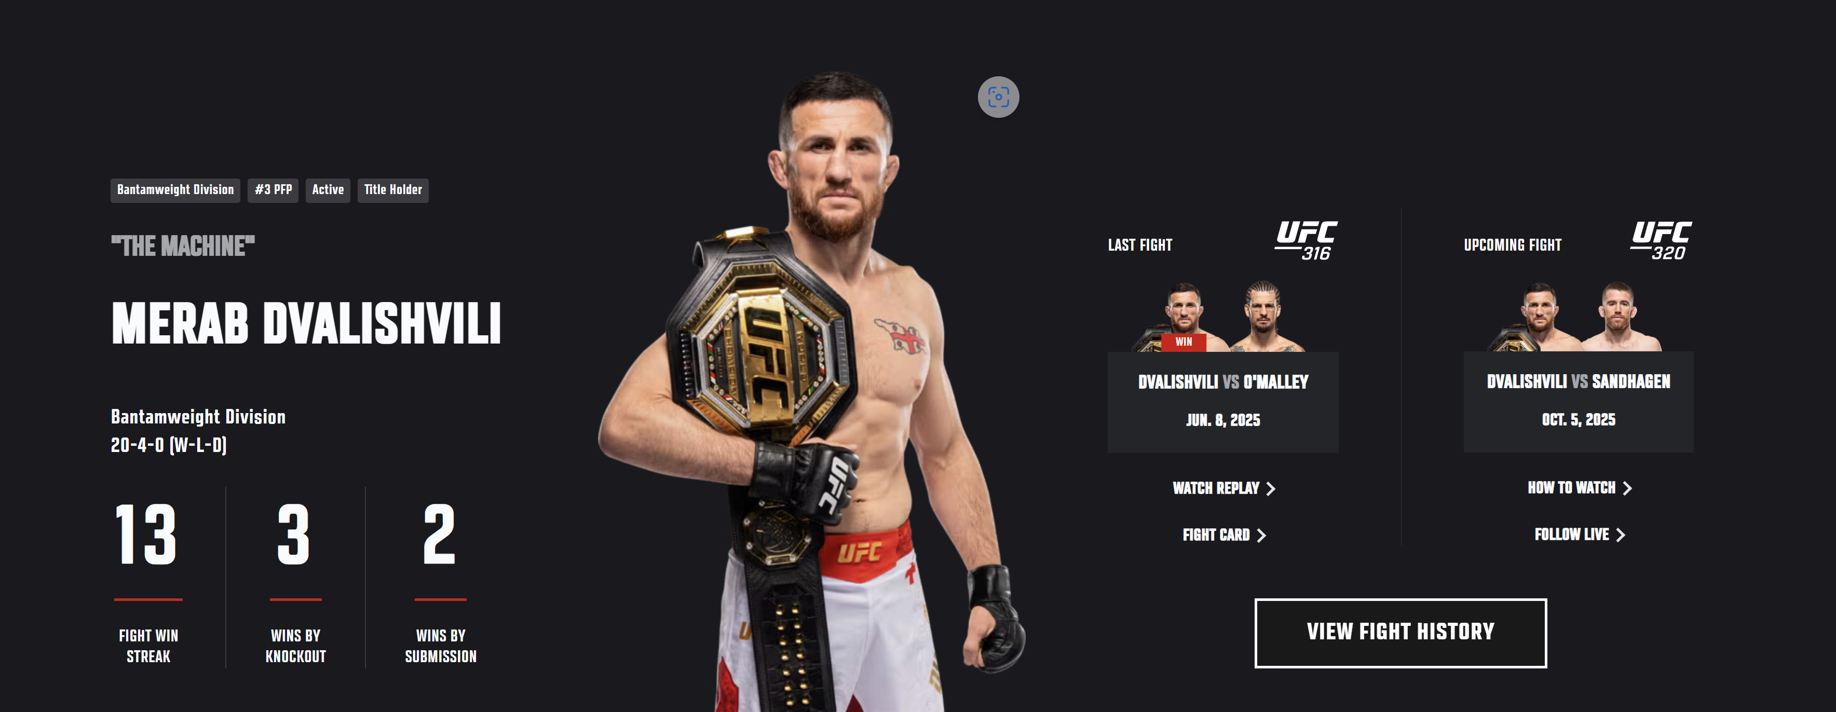
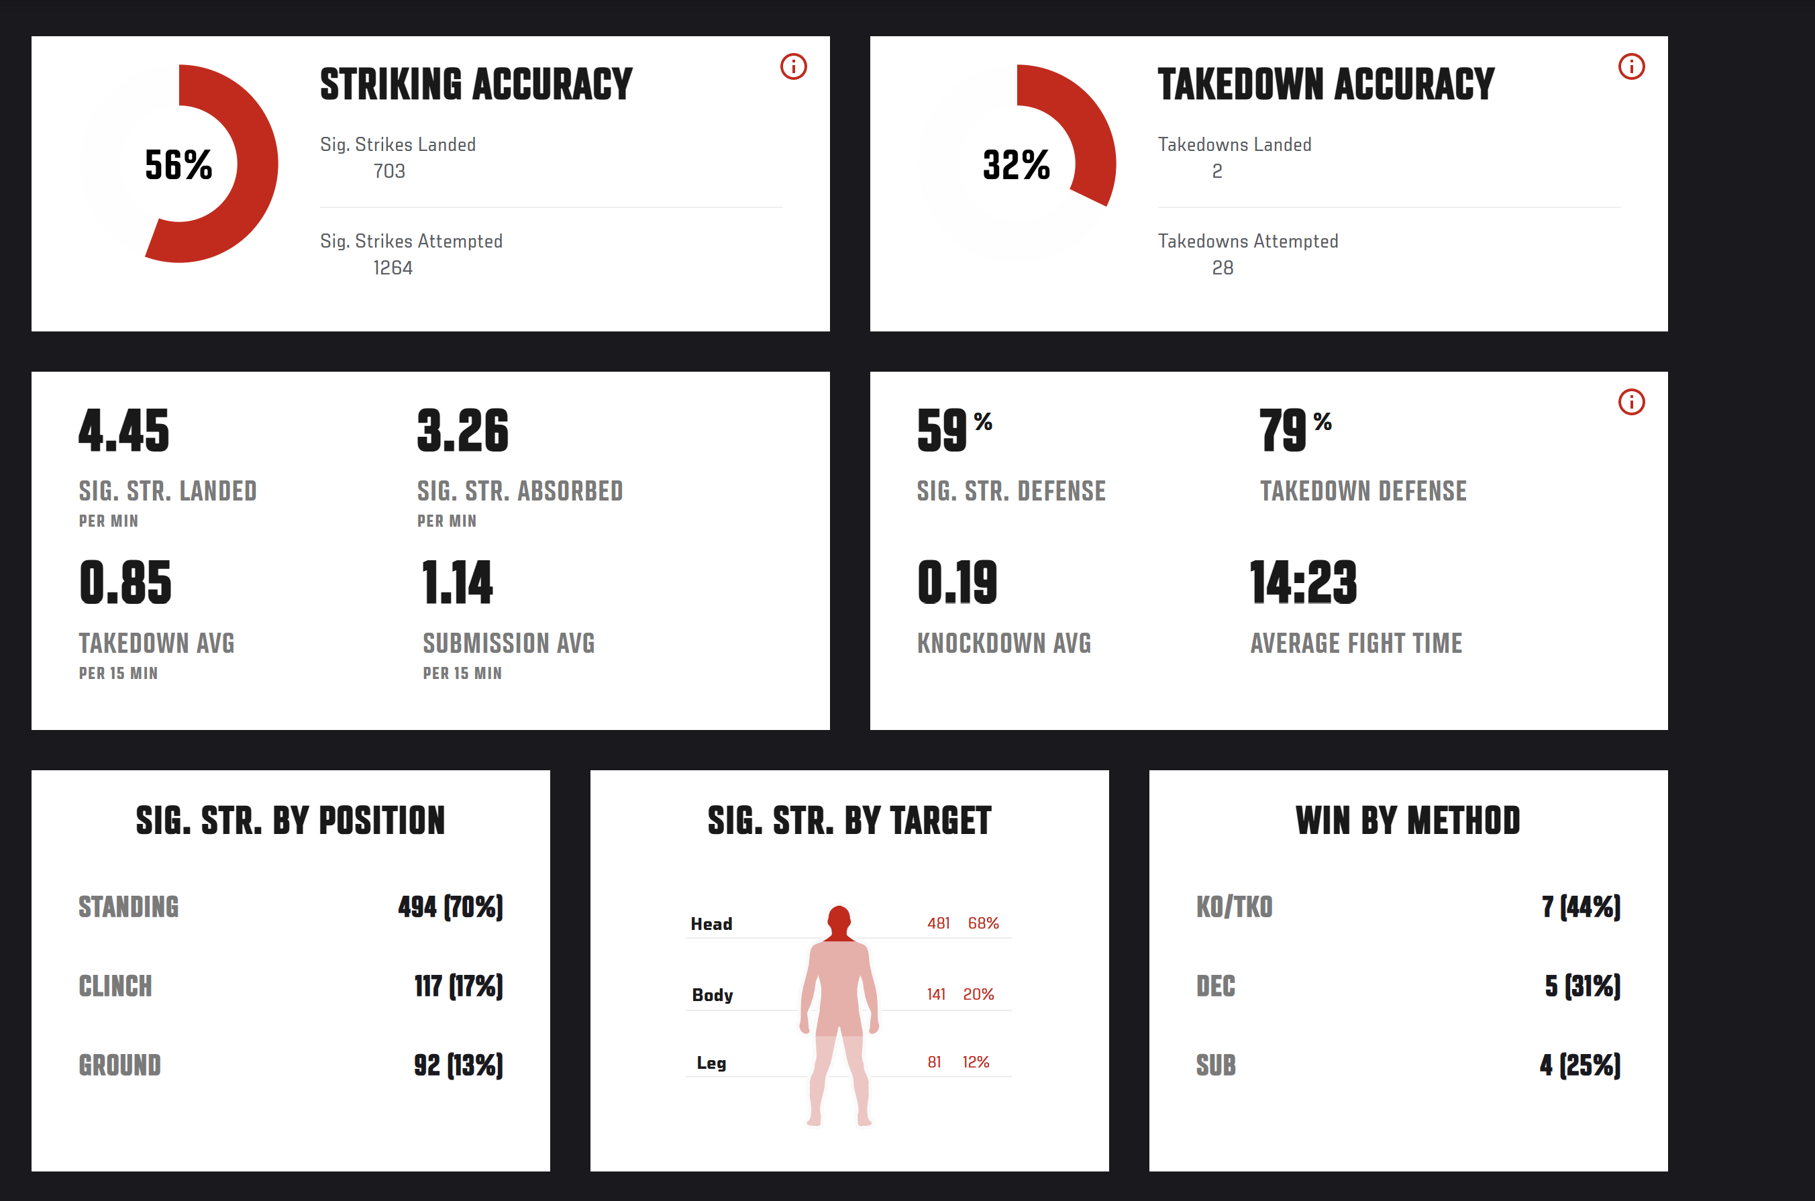

Takeaways
- I like how the front page shows all the rankings so compactly, but, in my opinion, they don’t show enough information. I will have to find a balance between something like this and a UI that’s too cluttered.
- I like the tag system; I can integrate this into SQL on fighter profiles.
- I like how the number of tables is more diverse than just having pie charts. In my project, I want to have a few more ways of showing the data to make the end user experience more interesting
Existing System Example 3 – Fight Matrix
- The table is very simplistic and efficient
- It is limited in what it shows compared to the others
- The points it shows are fighter scores calculated using predictive data and past data
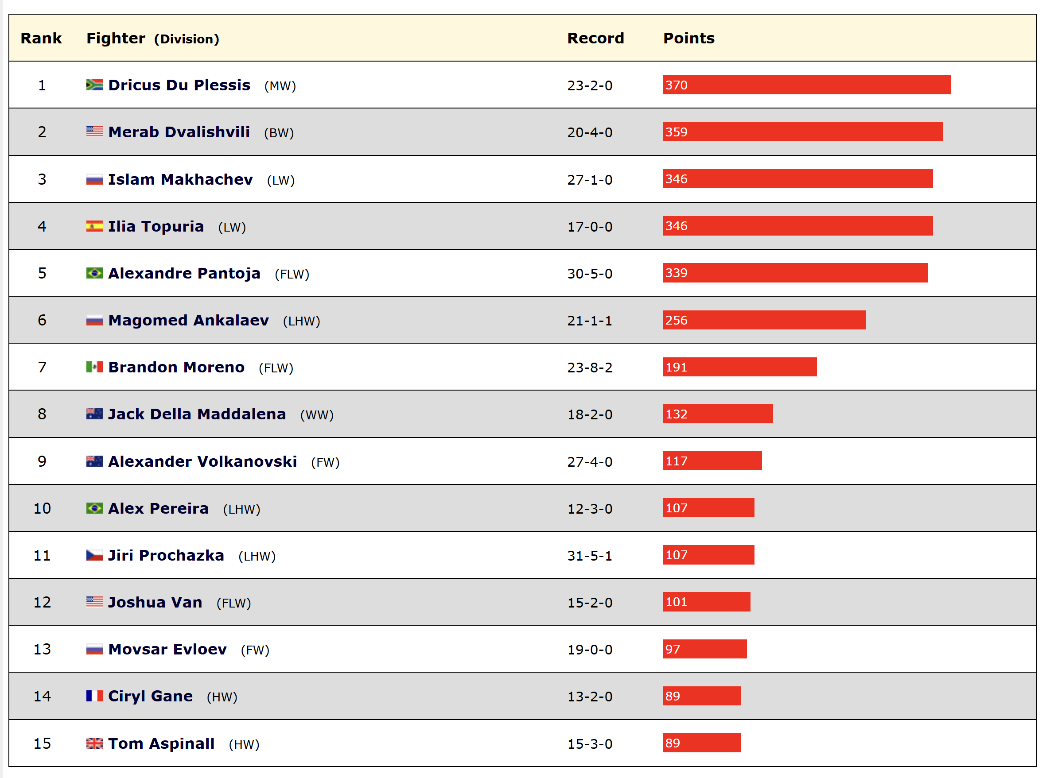

Takeaways
- I like how simplistic the table is, as it lets you take in the essential information quickly. I want to make a simplistic table like this in my project, but make each row a little bit taller.
- I don’t like how it doesn’t show who the champion is because that is very important contextually to someone’s ranking, so I am going to find a way to show what belts someone has.
- I don’t think that it’s necessary to show the point system directly to the user. I think that the ranking tells the user enough, and it takes up space where more important information can be.

Synopsis of Desk Research
Feature | Justification | Source
A High contrast, two-toned colour scheme | A High contrast, two-toned colour scheme is easier to read and more engaging to users. | Tapology
User votes | I’m going to include a user voting feature for fighters, which you can use to gauge the community approval of them. | Tapology
Searching for fighters | I’m going to include a fighter search feature so people can search for fighters they like | Tapology
Larger Table Format | I’m going to make a larger table format to make the information easier to digest and read. | Tapology
Fighter photos | I’m going to include fighter photos on the fighters’ profiles, and if you enter them into the odds calculator. | Tapology
Diverse Data Diagrams | I want to add different graphs to help users visualise the information given better and to provide a more engaging user experience. | UFC Official Website
Simplistic UI | I want to have a simplistic, more minimalist UI to make the UI easier to take in for users. | Fight Matrix

Stakeholder involvement in existing systems
Name |  | Description | Needs
MMA Fans (Example: fans at UFC China)   |  | - MMA Fans are the end-users who will look at the rankings and stats.  - They will also send requests to generate odds for fights.  - Using these stats and info they get, they could choose to purchase Pay Per View or attend events. | - MMA fans want a high-quality interface that is easy to use and visually appealing.  - They want quick access to specific fighter stats (short loading times, navigation)  - They want odds for fights that are as accurate as possible  - They want extra features to improve their experience, such as voting predictions for fights
To investigate MMA fans, I can do surveys to see what most MMA fans do and don’t like about MMA systems. I can also observe MMA fans on MMA websites to see how they navigate websites.
Fighters (Example: Demetrious Johnson, former UFC and ONE champion)   |  | - MMA fighters are the people whose stats from their bouts have been entered into the system.  - MMA Fighters aren’t necessarily going to use ranking systems, but they may use them to see their own stats or other opponents’ stats to research before a fight. | - MMA fighters are going to want to have an accurate representation of themselves on the system (accurate rankings and accurate odds)  - If they’re using the system to research the fighters that they’re competing against, they will also want an accurate representation of other fighters to get a good idea of who they are before they accept a fight with them.
To investigate MMA fighters, I can do an interview with a smaller MMA fighter to figure out what they want out of an MMA system.
System Admins | • MMA system admins are the people who put the data into the system and host the server that the end-users use.  • The admins may act as an individual entity, or they may be operating the system for an individual promoter |  | • MMA system admins are going to want the end-users to have a good experience using the system.  • They want a reliable and stable system and interface  • MMA system admins are also going to want to have good features that can attract more users over other ranking systems
To investigate system admins, I can also interview an MMA System Admin to figure out what features they like and don’t like about the MMA systems they implement
MMA Promoters  (Example: Dougie Truman, former Cage Warriors CEO)   | - MMA promoters are the people who run the championship/league that MMA fighters fight in.  - They will get system admins to run the system that the end-users use |  | - They want the MMA Fans to have a good experience with the UI (up-to-date data/easy to use interface)  - A promoter will also want the fighters fighting under their promotion to be represented accurately  - A promoter will want tools to show how entertaining a fight is going to be, because if a fight is shown to be entertaining, a fan is more likely to watch the fight.

Investigation Methods
Method Of Investigation | Justification
Method 1 – MMA fans questionnaire | MMA Fans will be the brunt of the users of my system. This means that there are going to be a lot of fans with a lot of different opinions about what they want and don’t want out of a system like this. To make as many MMA fans as possible happy, I can do a questionnaire which allows me to see the majority opinion.
Method 2 – Interview of MMA System admins | MMA system admins are just as important as the fans because the system admin is responsible for making the system, and talking to an admin will tell me what I need to put on the admin side.
Method 3 – Observation of the MMA fan | To counteract the generalness of doing a questionnaire, I am going to observe an MMA fan to see how fans directly interact with an MMA website and what problems they come across and things they find good about the websites, etc.
Method 4 – Interview with an MMA fighter | MMA fighters are arguably the most important part of this system and are the base of the system, so making sure their needs are met as stakeholders is imperative. To figure out what they need, I am going to interview a smaller MMA fighter.

Investigation Method 1 – Questionnaire of MMA fans
Here I am investigating MMA fans using a questionnaire on google forms. Here are the questions I gave the fans and the answers they gave me:
The goal of this first set of questions is to figure out what MMA fans want on the main leaderboard table
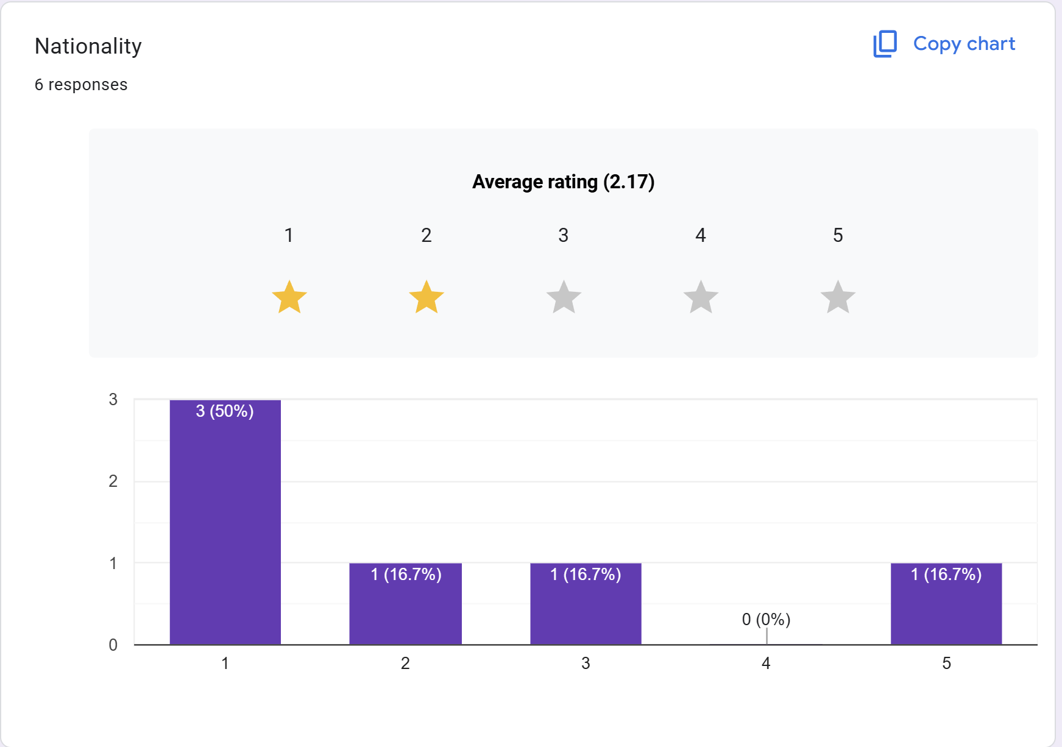
What I’ve found out from this question is that most people don’t really care about nationality, so I don’t think it’s necessary to add nationality to the table

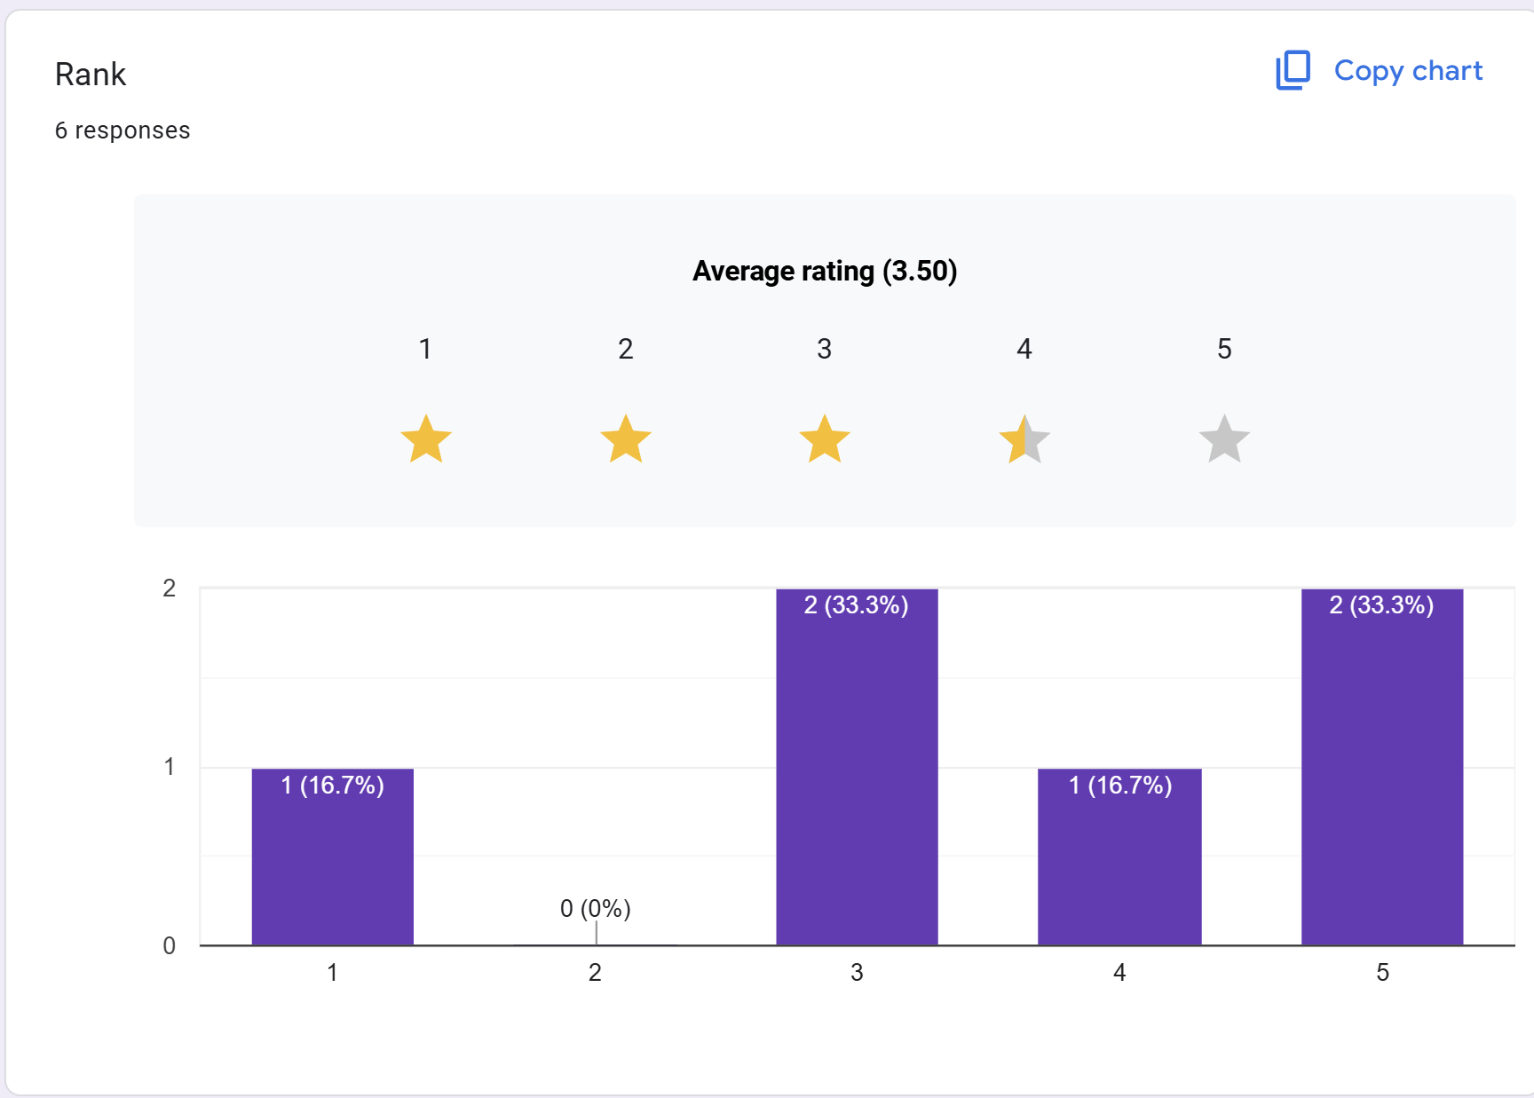
What I’ve found out is that most people lean towards rank being important, so I am going to make sure it shows the distinct rank number on the table as opposed to it being implied by the order that you get when you open the leaderboard page.
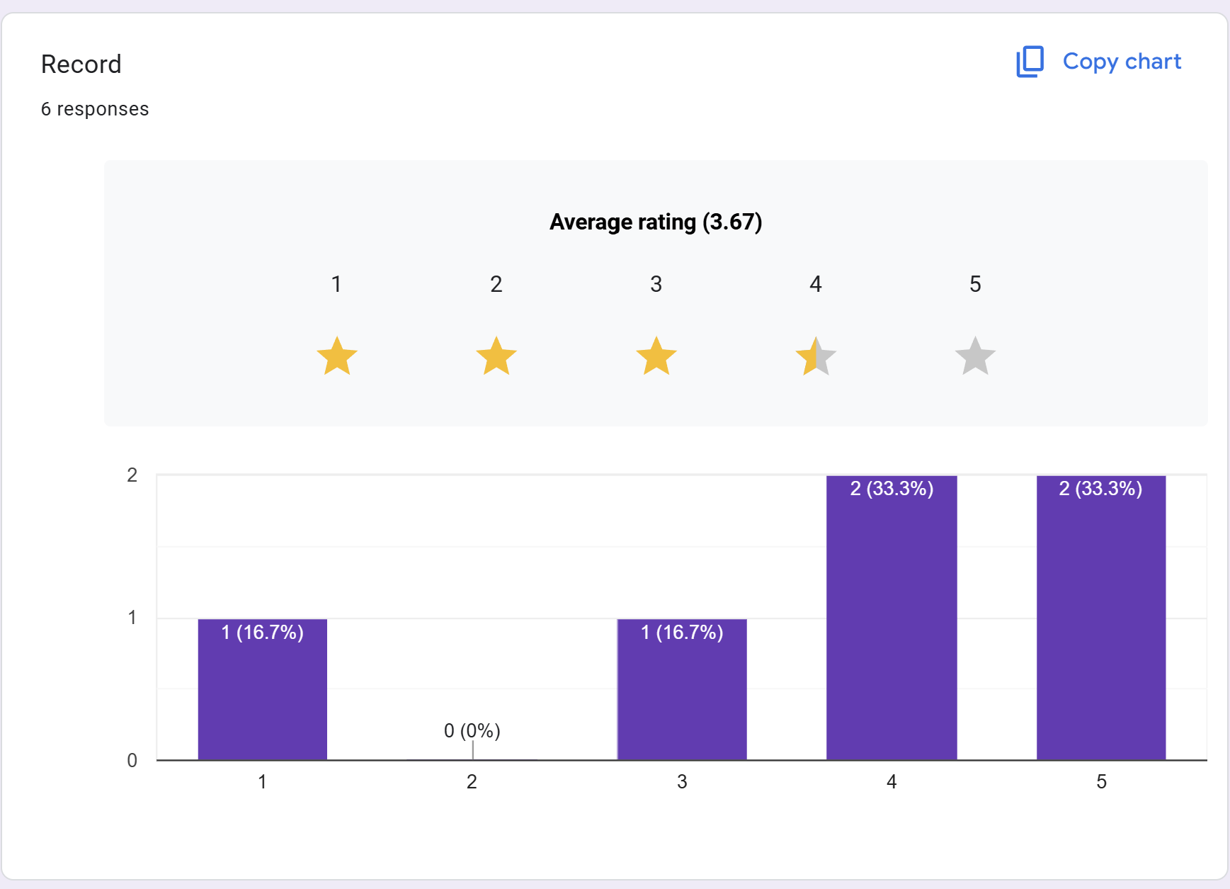
What I have found out from this is that the majority of people believe that a fighter’s record being displayed is a very important thing to have on a table

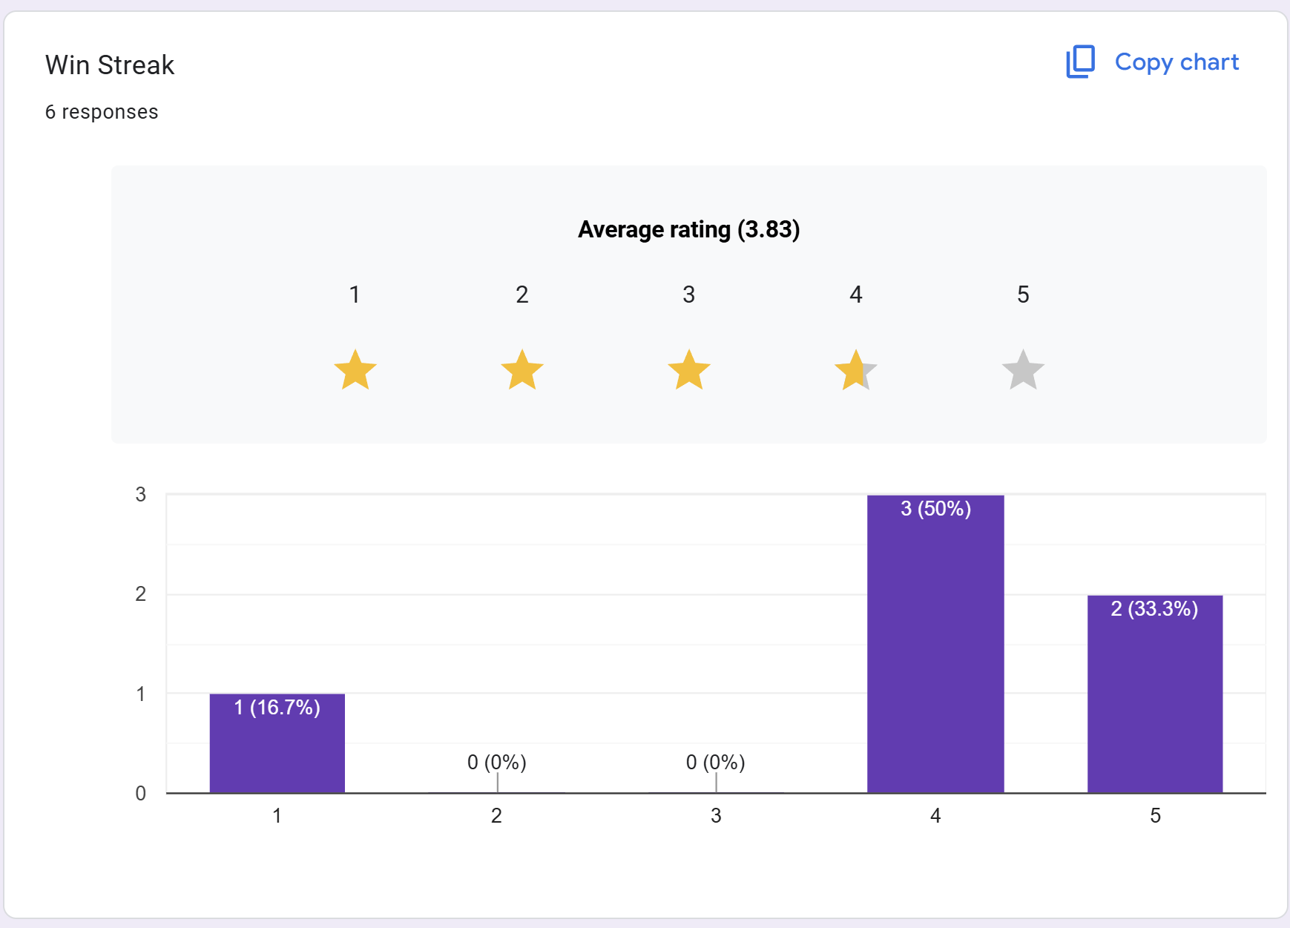
Out of all of the subquestions here, this one has the 2nd highest rating on average. I am going to make sure to include the win streak in the leaderboard
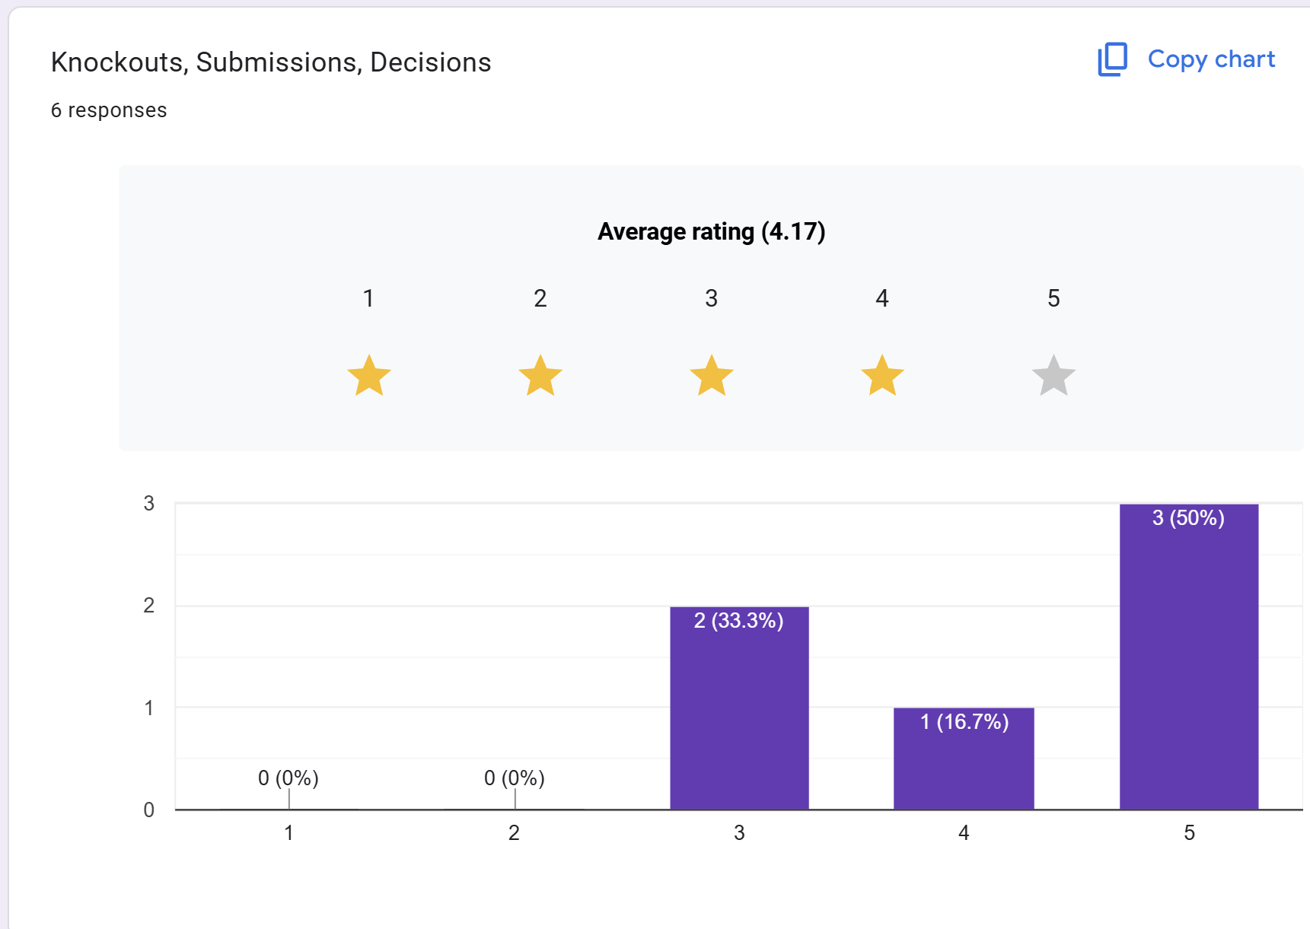
This one has the highest rating. Because of this part of the research, I’m going to try to split submissions, knockouts and decisions into different tables.
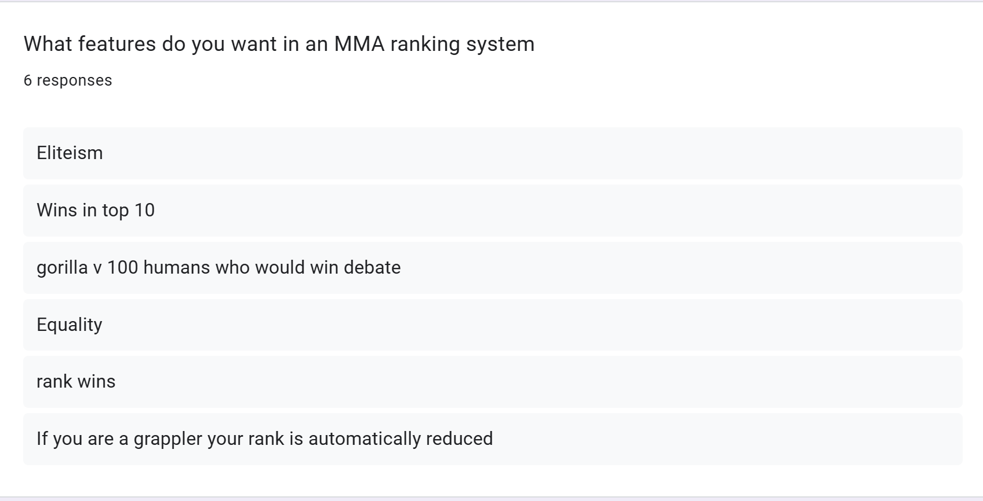
Aside from the non-serious answers, which are guaranteed in a questionnaire, I think the idea of having the wins you have in the top 10 (of your weight class, presumably) is quite a good idea.
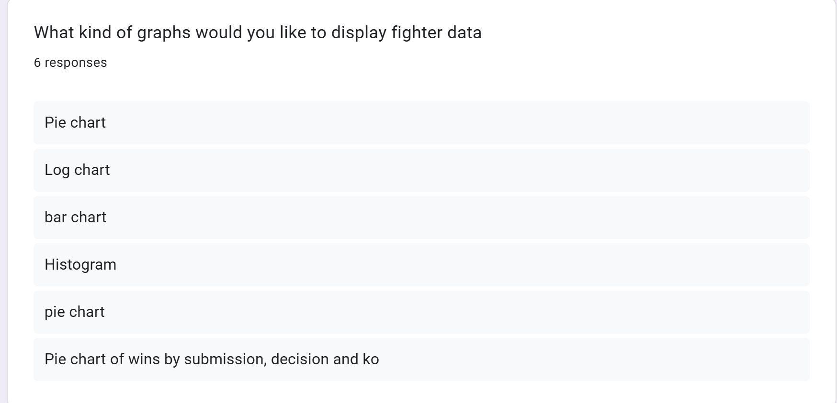
Pie charts seem to be the chart that MMA fans like the most. I like the pie chart of wins by Submission, Decision and KO idea.

Investigation Method 2 – Interview With MMA system admin
For my second investigation method, I will research system administrators, as they will inform me about the key requirements for the administrative side of the program, such as reliable and efficient data entry, and ease of use when inputting data into the system. I will conduct this by emailing the administrators of larger MMA statistics websites.
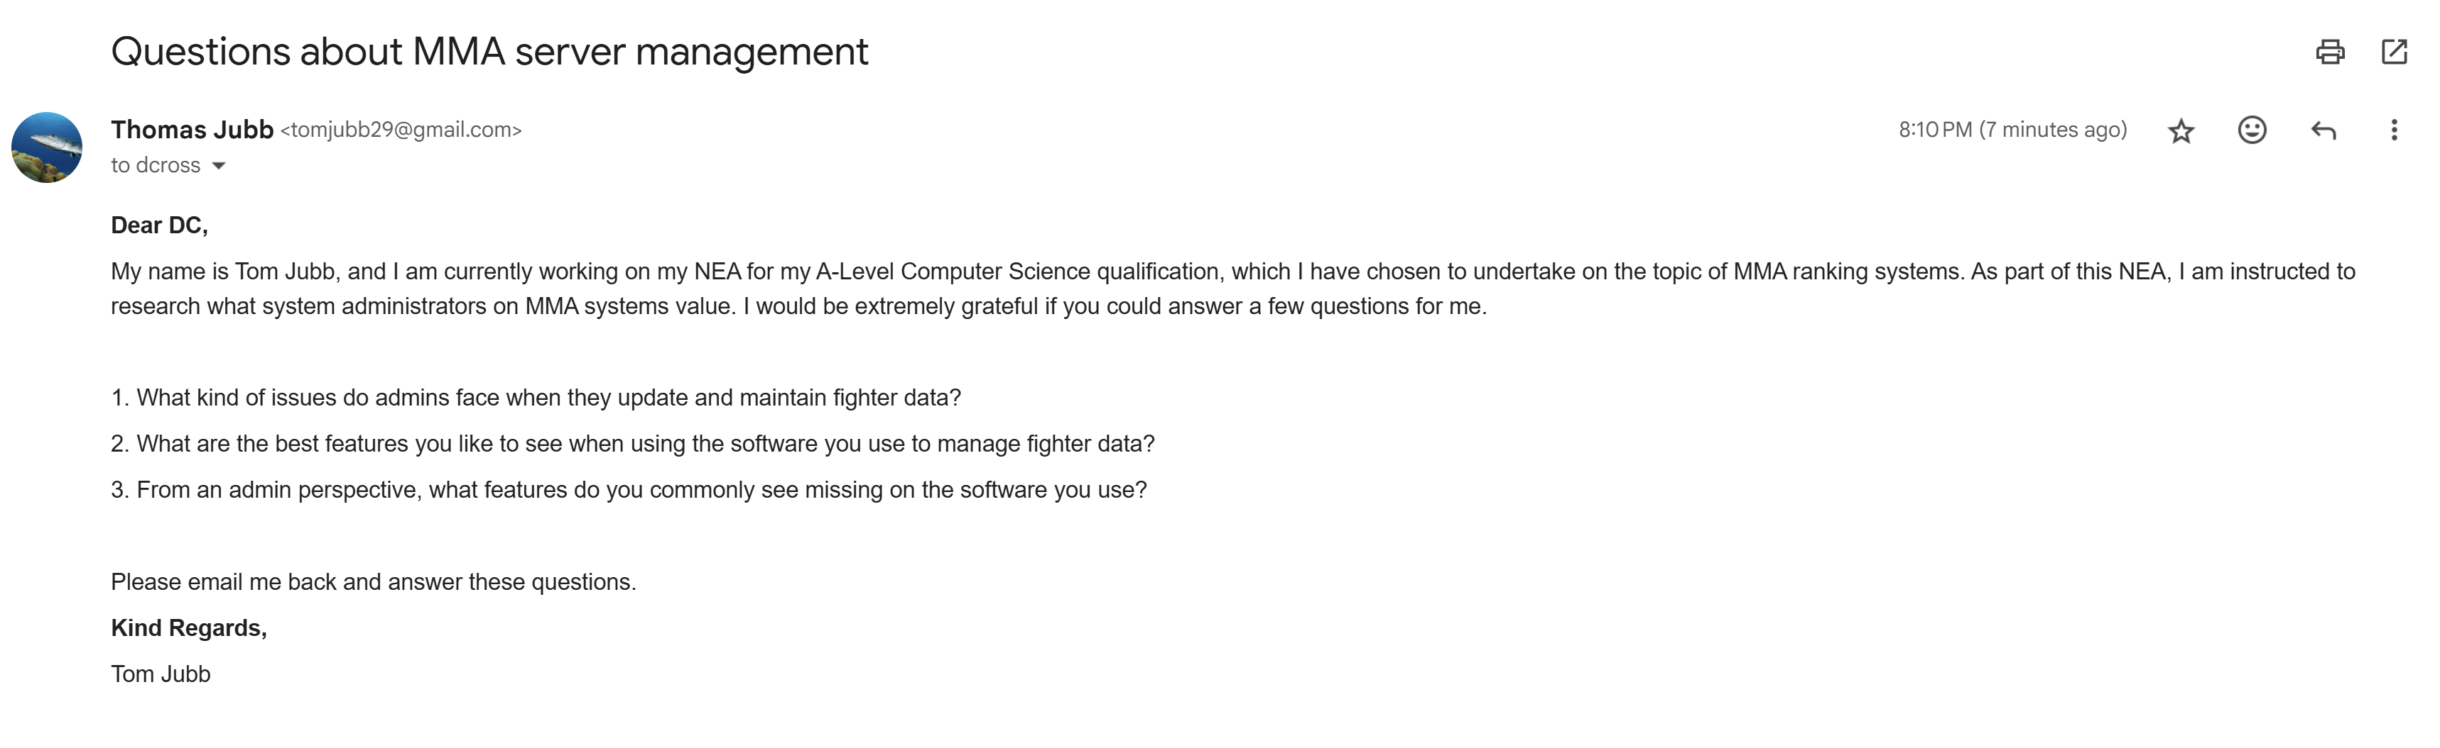

The admin replied with this:
1. What kind of issues do admins face when they update and maintain fighter data?
The biggest issues normally come from data consistency. When multiple people are updating info about a single fighter at the same time, you get problems like duplications, misspellings or incorrect stats.
2. What are the best features you like to see when using the software you use to manage fighter data?
I love a good searching system. I also like features that make sure data is validated.
3. From an admin perspective, what features do you commonly see missing on the software you use?
I’d like to see better anomaly detection, something that catches odd data (like impossible win streaks) automatically.
Conclusion
From this research, I am going to make sure I can add good data validation features that ensure all the data is validated, I’m going to make sure I have a good searching subsystem, and a feature that catches odd data.

Investigation Method 3 – Observation of MMA fan
For my third method of investigation, I want to find out more about MMA fans and how they navigate MMA websites. I can do this by observing MMA fans using an MMA website. This will tell me what people like and don’t like about MMA sites in practice, what pages of the website people are most likely to look at, and what data people are most likely to find interesting.
The fan I chose first had a look at the featured fight and then looked at the individual stats of a fighter (Diego Lopez). He looked at Lopez’s fighting history and upcoming fights, and from there, he looked at his upcoming opponent, who is Jean Silva. From there, he looked at the info on Jean Silva’s previous fight against Bryce Mitchell. After that, he clicked the website’s logo to go back to the homepage. After this, he searched for another fighter (Jon Jones), but he encountered an issue with the search because it brought him a fighter who wasn’t Jon Jones.
From this observation, I have learned that MMA fans tend to go for events first and then view the context of the fight by seeing the fighters that are fighting. They also do this in reverse by looking at a fighter’s fight history. They also tend to view fighter information more than fights themselves.
Because of this research, I am going to make navigation between fights as easy as possible. I also need to make sure that the search system is robust to stop errors like what happened when the fan tried to search for Jon Jones.

Investigation Method 4 – Interview with an MMA fighter
For this investigation method, I have found an MMA fighter who has quite a bit of experience and was willing to sit down and have a chat with me about what he likes out of an MMA system.
The questions I'm going to ask him are:
- What things do MMA leaderboard systems like Tapology or Sherdog do for you that you like and why?
- Do you use MMA leaderboard systems regularly, and why?
- How important is your presence on websites/systems like the 2 I mentioned above for getting fights and promotional deals?
- Do you think the current systems that are in place are fair to you? Why/Why not?
These are his answers:
What things do MMA leaderboard systems like Tapology or Sherdog do for you that you like and why?
One thing I really like about those sites is that they keep all my fight records in one place. They show my history, record and streaks which everyone, like promoters, can see. I can also use it to see the level of opponents whom I am offered before I decide whether to take a fight or not.
Do you use MMA leaderboard systems regularly, and why?
Yep, I use them quite a lot. Not just because I am a fan of Mixed Martial Arts, but I also use them to track my opponents to see what fights I want to chase.
How important is your presence on websites/systems like the 2 I mentioned above for getting fights and promotional deals?
It’s quite a bit important. Promoters, managers and sponsors are always looking at these websites and deciding fights based on them. Sponsors will look at records for authenticity.

Do you think the current systems that are in place are fair to you? Why/Why not?
It is quite a mixed bag. They are fair in the way that everyone gets to see your stats, but the thing is, with a smaller fighter like me, my data doesn’t update quickly.
What have I learned from this interview?
To satisfy fighters as stakeholders, I need to make sure all data is as up-to-date and accurate as possible. To do this, I need to make sure updating data on the system is as easy as possible, which I can do by adding more ease-of-use to the admin side (searching, etc). Also, when an update is made, my system should check for data inconsistency and redundancy, as well as all of the other data stuff.

Synopsis of Investigation Methods – Features to add
Feature | Justification | Source
Display rank number on the leaderboard table and fighter profile (from the algorithm, not from official rankings) | This can help people contextualise fights to rankings, which helps you envision how the fight is going to play out, as you have a metric that tells you how a fighter’s career is currently | Investigation Method 1 - Questionnaire
Display record on the leaderboard table and fighter profile (I’m going to split this with win/loss/sub/ko/dec) | This not only shows how good a fighter is compared to other fighters, but you can also gauge how a fighter is stylistically by the way a fighter finishes fights. | Investigation Method 1
Display the win/loss streak on the leaderboard table and the fighter profile | When a user looks at the leaderboard, this shows how a fighter’s career is going and what’s at stake for an upcoming fight | Investigation Method 1
Feature | Justification | Source
Display notable wins (meaning for these wins in the top 10 rankings of your weight class) on the fighter profile | This allows a user to figure out a fighter they don’t know much about, to see how they go up against fighters that they do know about | Investigation Method 1
Display chart data on the fighter profile (I am going to add a pie chart for methods of winning/methods of losses) | The reason why I want to put this info into a chart as well as in numbers is that it helps users to visualise everything | Investigation Method 1
Validate all data and check for data inconsistency (range checks, checking for inconsistency and redundancy, etc) whenever an update is made. | This makes sure that the info is accurate, up to date and reliable for all of the stakeholders. It also makes the system administrators’ lives easier because they don’t have to validate the data themselves. | Investigation Methods 2 and 4
A good, accurate searching algorithm to search through the admin side fighter list | This makes it easier for system administrators to check data in the fighter list | Investigation Methods 2 and 4
Good navigation UI on the user side, making all pages accessible in at most 3 clicks | This makes it easier and quicker for users to find the information they want without getting lost | Investigation Method 2

Document Collection
Elo Rating
The reason why I have collected this document is to figure out how the ELO rating works because the ELO rating is used in a lot of MMA websites to determine their rankings.
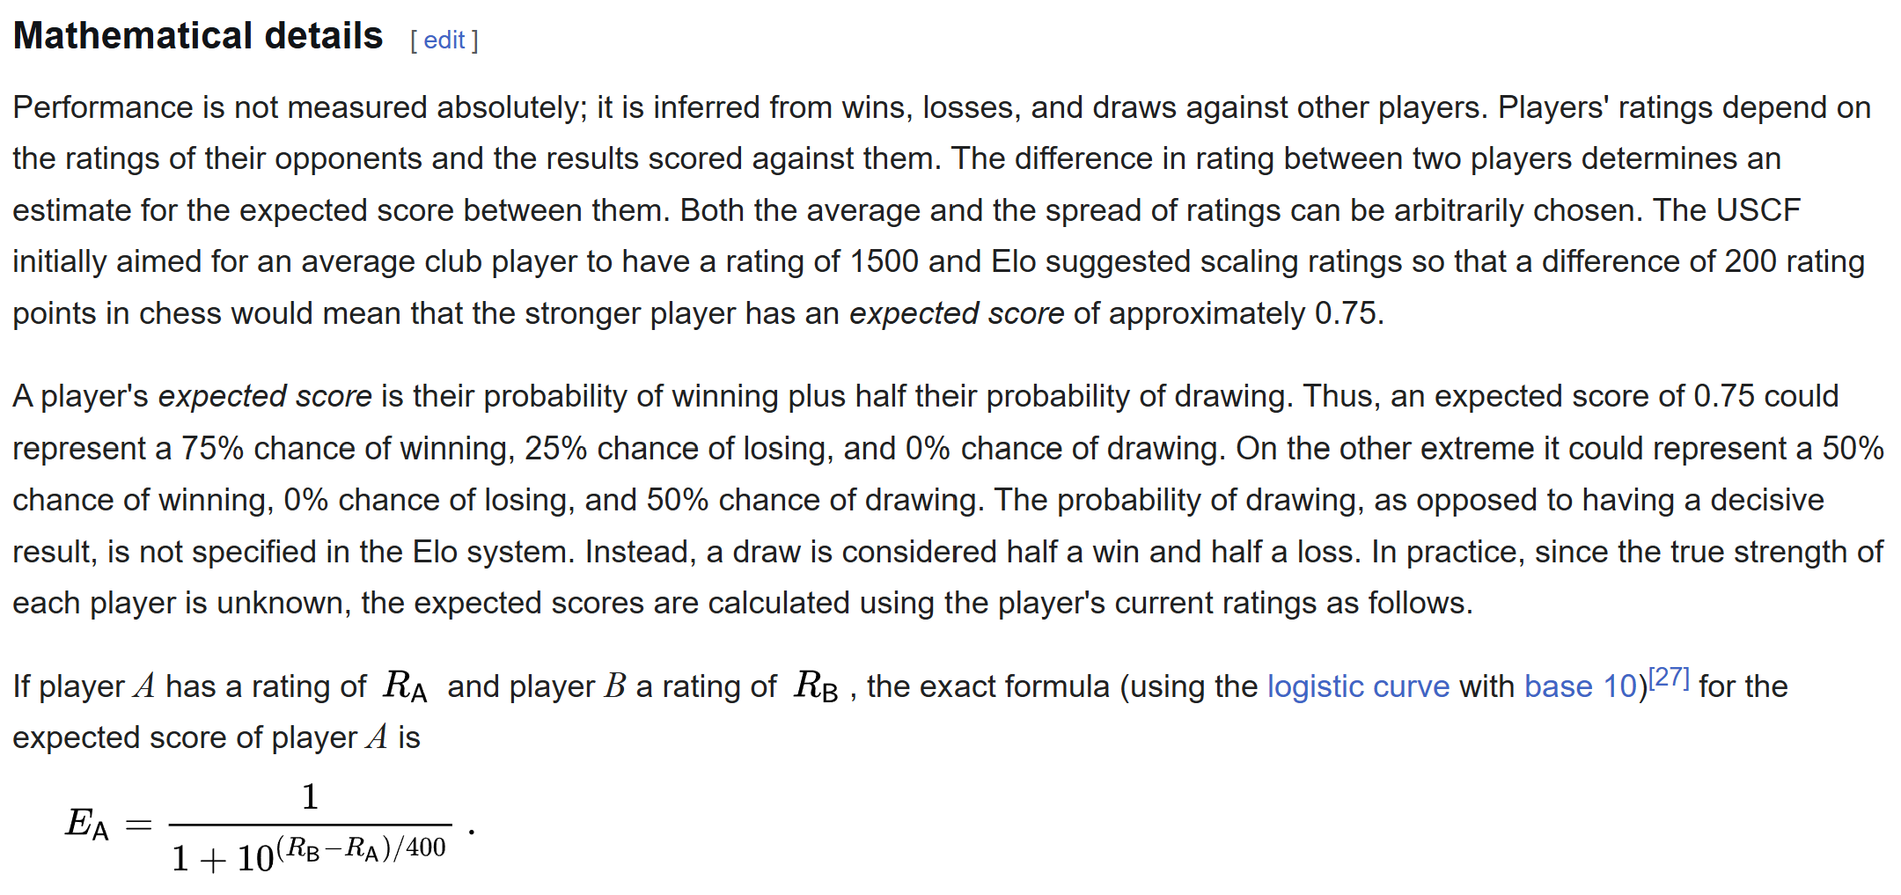
This shows me that ELO is quite intricate but it doesn’t take into account things like inactivity or age because they don’t matter as much in chess (the thing that elo is made for) than it matters in MMA.

Fighter data
This document is from tapology and tells me what data is being held by tapology for each individual fighter which probably matches up to other MMA sites. I have already looked at tapology’s interface in the desk research but I want to look more in depth to identify data inputs.
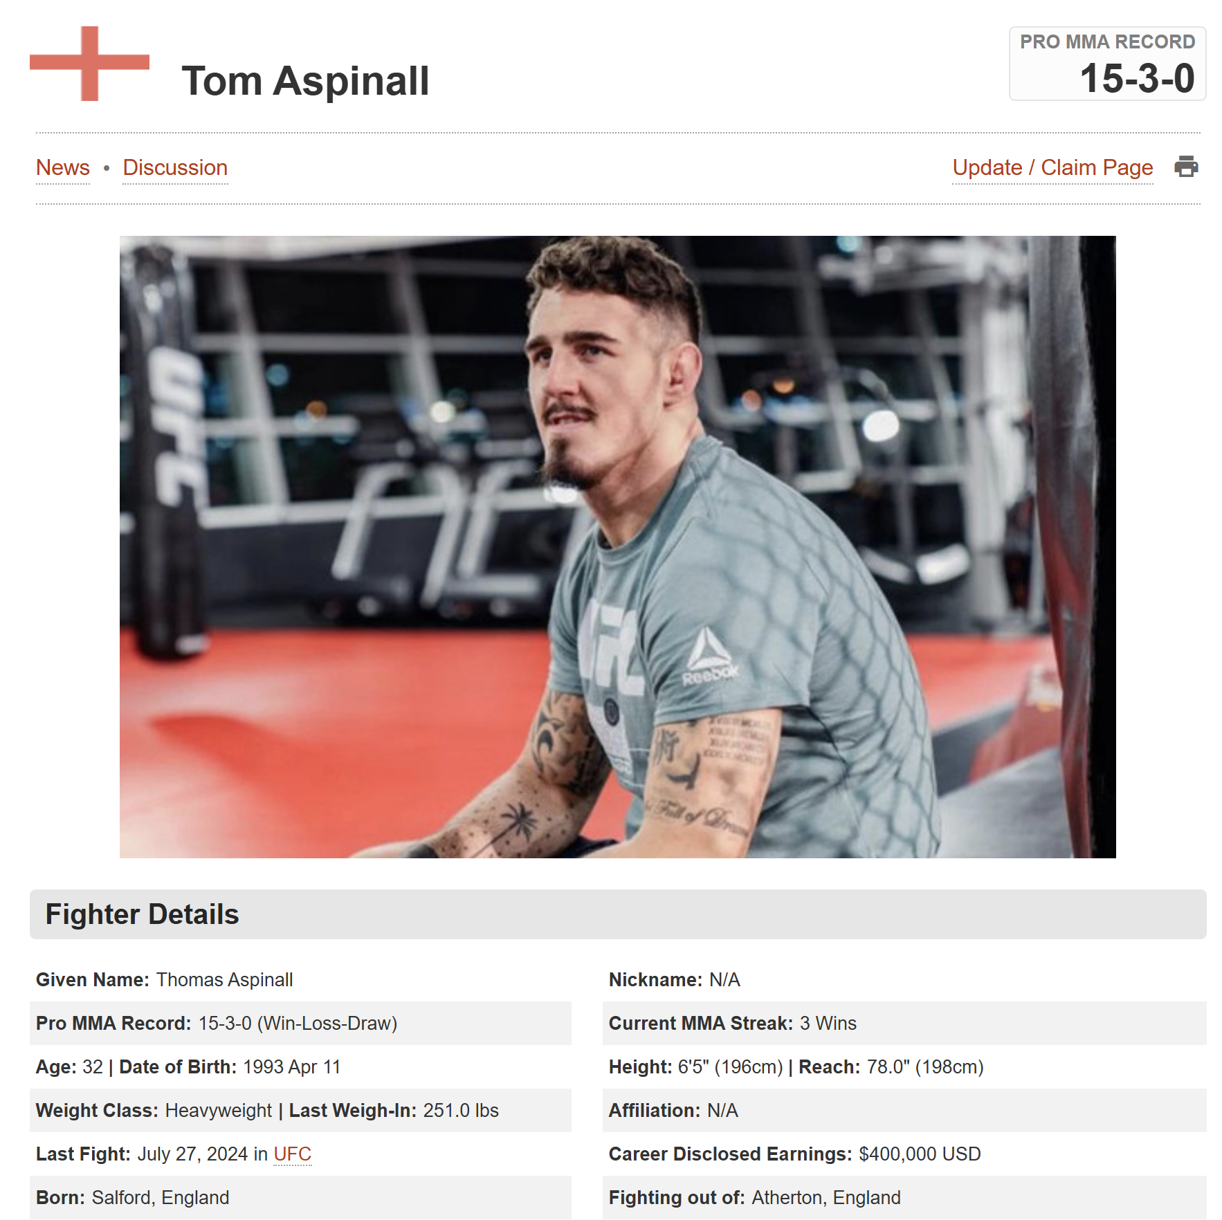
From these screenshots we can tell that tapology gives outputs like names,streaks,nicknames,pro mma records,winstreaks, age, dob, height, reach, weight class, gym, last fight, career earnings, birthplace and gym location. It also holds pro mma ko wins/losses, submission wins/losses and decision wins/losses. For each pro mma fight it also shows what promotion they fought in.
For each fight it outputs the event, two fighters, the way the fight ended, the round time the fight ended, the promotion it was in and the method of winning
What it probably takes as inputs are names,nicknames,age,dob,height,reach,weight class and gyms and birthplaces for fighters and then in another fight table it stores the promotion of a fight, the two fighters, the method they won, the round time they won, the date of the fight, the winnings of the fight if declared)
What these documents also tell me is that tapology probably prefers manual data entry because the methods of winning are very specific meaning that they were entered by a human.

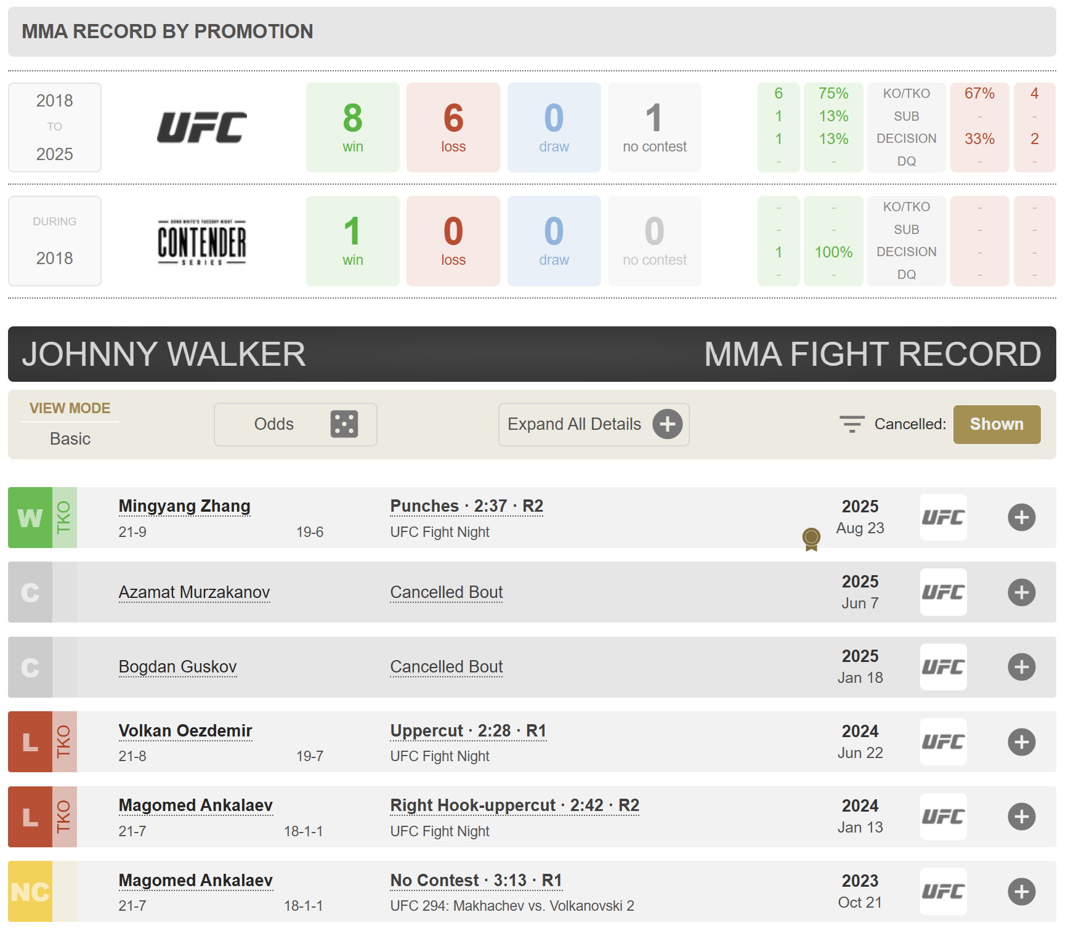
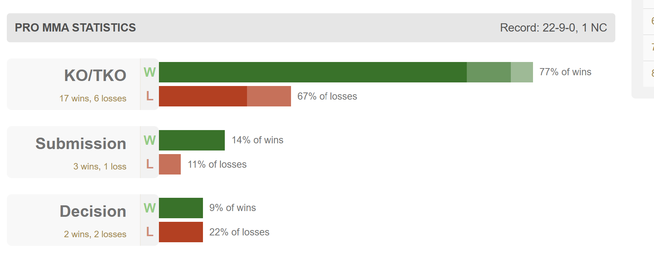

Processing
Name | Input | Processing | Output | Comment
Ranking Calculation using ELO model in current system(s) | Fighter A ELO rating  Fighter B ELO rating  Fight Result  K constant (changes with experience) | - Calculate expected score for each fighter using ELO algorithm  - Update ratings  - Round to nearest integer | Updated fighter ELO rating  New leaderboard order | Doesn’t take fighter age or inactivity into account (which is way more important in MMA then it is in chess). Using Glicko-2 which does take that into account would be better
Leaderboard sorting in current system(s) | Leaderboard table  Filters  E.g. All fighters who have held a UFC heavyweight belt | Sort list in ascending/descending order with an SQL query E.g.  “SELECT * FROM LEADERBOARD WHERE Belt=UFCHEAVYWEIGHT ORDER BY Asc;” | Leaderboard view ordered by filters  E.g.  “Tom Aspinall, Jon Jones, Francis Ngannou, Stipe Miocic” | Can be slow for bigger databases, needs to be optimised with something like indexing
Leaderboard search in current system | Leaderboard table  Search Term  E.g. John Jones | Search for all terms which are within around 2 edits to the original search term string (Levenshtein distance search)  E.g. Search terms within 2 edits of John Jones | Leaderboard view filtered by people with names like search term  E.g. Jon Jones, John Jones | May be a bit slower on larger databases and may need more edits allowed to account for big names which can have a lot of typos
Data Validation in current system | New data entry into database  e.g. (Cyril Gane, 6’4’’, Heavyweight) | Check all required fields are filled  Check all data types are correct  Check for data duplication | Show error if invalid  e.g (“Validation error- No MMA record entered) | Prevents errors in leaderboard but doesn’t stop things that are statistically impossible
Odds Calculation in current system | Fighter A ELO  Fighter B ELO | Convert elo ratings into probability  P(A beats B) = eloA /(eloA+eloB) | Percentage probability of fighter A or B winning | Works well with little data but doesn’t take things like fighter activity into account

Limitations
- Rankings take about 48 hours to update. This leaves fans waiting to see the impact of fights, which can be past some people’s attention spans, and puts less on the table for the fighters as they won’t really see the effects on the system for 48 hours.
- Some systems are cluttered with information that doesn’t really matter to the casual viewer, and then also go and not show enough context, like who is a champion or not.
- Smaller promotions don’t even have proper records, meaning that if you are a smaller fighter, you aren’t represented.
- A lot of MMA websites don’t let you filter enough data, meaning that you can’t find the records you really want to find.
- A limitation that the current systems have is that they rely too much on humans, and that creates bias. The way the system in the UFC works is that 20 sports media people do a vote over the rankings. Not only does this system create bias, but it also could lead to corruption and inconsistencies in data.
- Searching can be inaccurate on some MMA websites.
- A lot of MMA websites don’t value user input.
- If an MMA site uses just the ELO system to calculate MMA fighters' scores, then they don’t consider things like activity and age.

Working specification
I am going to make an MMA program with two sides. The main side will be the user side, where there will be a league table with individual fighter stats, such as nationality and record. You will be able to search for fighters based on these factors. Each fighter will have their own page, which shows their record, fight stats such as submissions and knockouts, fight history and upcoming bouts. The program will also feature an odds calculator, which will use a combination of the Glicko 2 model and the Bradley-Terry model to calculate odds. The program will also feature an entertainment predictor. The way this will work is by taking a short survey at the beginning, which will determine what the user likes or not. From this survey, the system will determine how entertaining a fight will be for you. Users will also be able to vote on fights based on entertainment.
On the admin side, you will be able to input data about fighters and fights manually through a simple interface. However, you will be able to use a UFC scraper as well.
The database will be on SQL, and the UI will use QT with a high contrast palette and simplistic visuals. The system will be heavy with visuals, with graphs such as heat maps and pie charts to show analytics about fighters.

Justifications of the methods to be used.

Firstly, for the UI, I think I will use QT Designer. I am doing this because I like how it integrates with other Python packages, and it removes an extra layer of processing that you would get with Flask, as you need to consider more server communication. This means I can allocate more resources to processing. It also means that when you get the Python programme, it works straight away, whereas with a serverless Flask approach, the user would need to worry about more things, which isn’t ideal, especially if the MMA fan doesn’t have much technical knowledge.
I am going to try out the UFC API with my prototype for data scraping for importing UFC data (for demonstration and home use purposes) because it is the best one to integrate with my SQL databases due to it being in Python, which is the primary language I am using to develop this program.
For my odds calculation. I think I am going to try to use the Bradley-Terry model, but make it go off an ELO score calculated by the Glicko-2 Model. That way, I can account for the lack of data, but I can add more accuracy if there is more data.

Objectives and success criteria
1.The system will generate ELO scores for every fighter inputted by a system admin using the Glicko 2 model and output a ranked leaderboard
2.The leaderboard will display the fighter's name, rank number, record, win/loss streak, weight class and methods of winning (number of subs/decisions/kos)
3.The table will be sortable by all displayed factors, as well as weight class, nationality, and the belts they’ve held
4.On the user and admin side, you will be able to search for a fighter's name using a Levenshtein distance system.
5.On the user and admin side, you will be able to click on a fighter’s row and then see their profile come up
6.The fighter profile will feature a photo of the fighter, their past fight history, win streak, upcoming fights, statistics (wins/losses by KO, submission, decision) and belts
7.The fighter profile will also show a pie chart that shows wins to losses and then decomposes to subs/kos/decisions to help users visualise the info.
8.The fighter profile will also show a table that lists the wins that the fighter has against the people who are currently ranked in the top 10 of their division.
9.The system must take an input of two fighters and give the odds of either of them winning by putting the ELO score they have through the Bradley-Terry model.
10.Upon first use, the system must prompt the user to make a profile so they can answer a short survey about what they find entertaining about an MMA fight. Using this, the system will be able to show how entertaining a fight is going to be to you based on what you like from the survey.
11.Users will also be able to vote on how entertaining a fight is going to be
12.Admins will be able to manually input fighters and fights
13.Admins will also have the option to use a UFC scraper.
14.The system will validate inputs by rejecting duplicate data and incorrectly formatted records
15.The system will use an SQL database to store data
16.Rankings need to update when you enter fight results automatically
17.The UI needs to be implemented with QT designer
18.The UI needs to be simplistic and easily navigable (needs to follow the 3-click rule)
19.The UI needs to be two-toned and quite saturated to make everything easily readable (be accessible for colour-blind people if possible).
20.The tables in the UI are going to be quite large.
21.The user needs to be able to navigate between the league table, fighter profiles, and the odds calculator in as short a time as possible.
22.The system will take a survey from the user at the beginning and make a profile that says what they find entertaining and not
23.Users will be able to vote on fighters and give them a percentage approval rating
24.The system will give each fighter a score according to the fighter’s info to determine how entertaining the user will find the fighter.
25.When the admin makes an update on a table, the program will validate all of the data,check for inconsistencies, check for data redundancies, check for statistical anomalies

